Andrew Ahlstrom

Notes: Rust

**Rust is strongly typed with NO COERCEMENT / CONVERSIONS**

# Cargo (creating a new rust project):

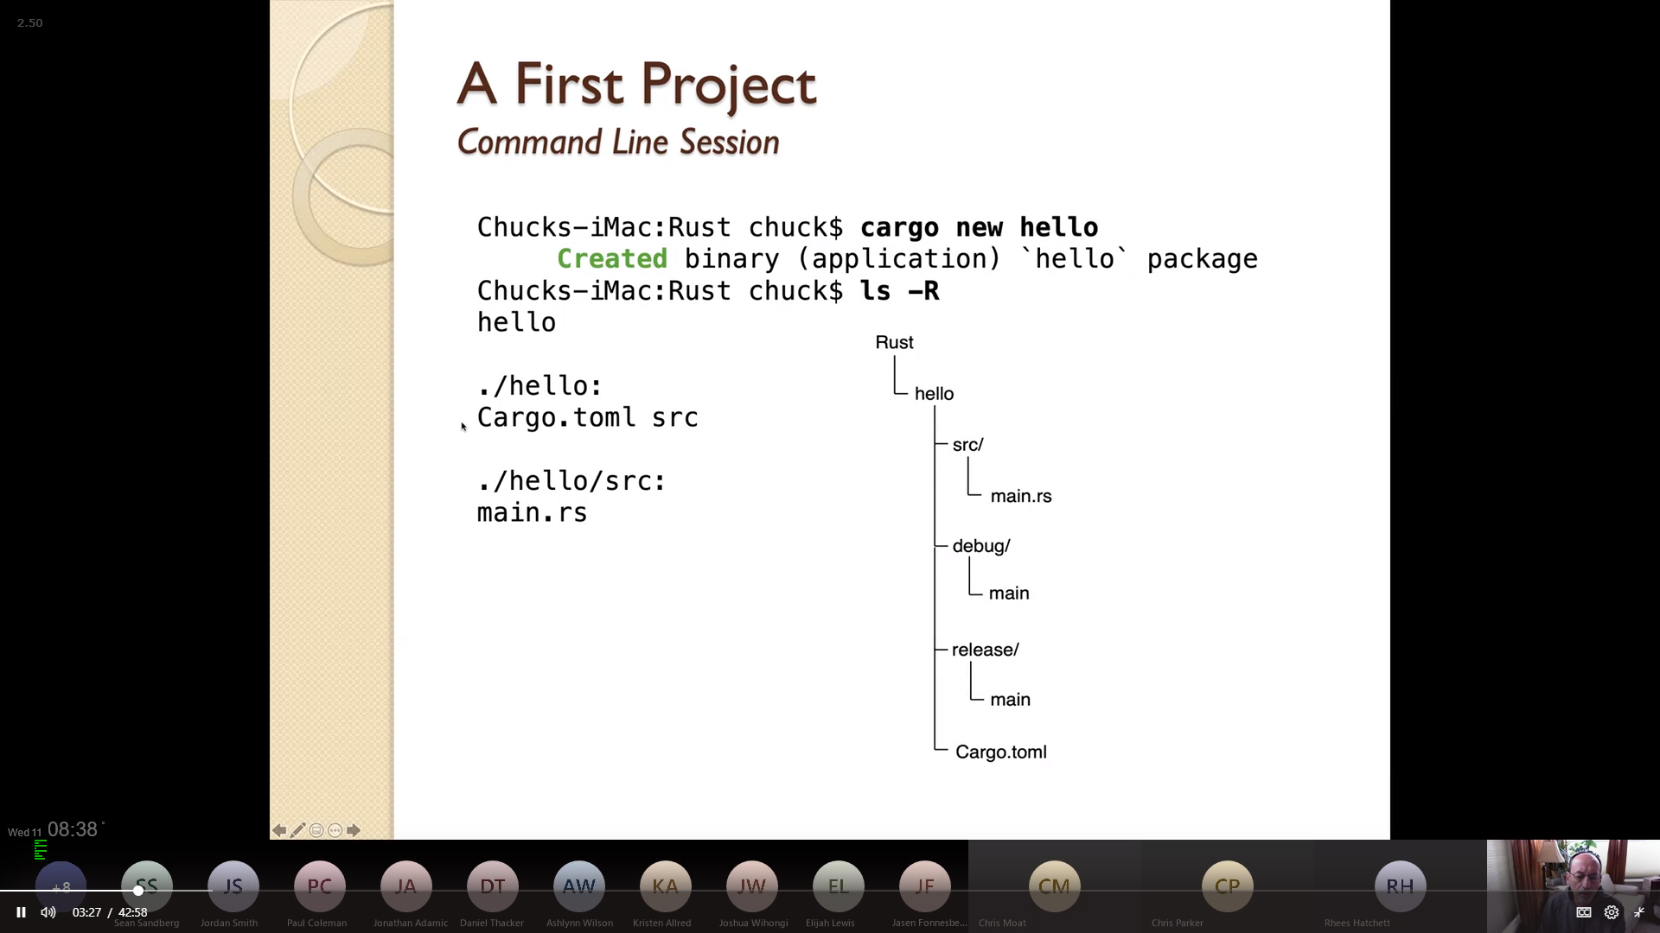

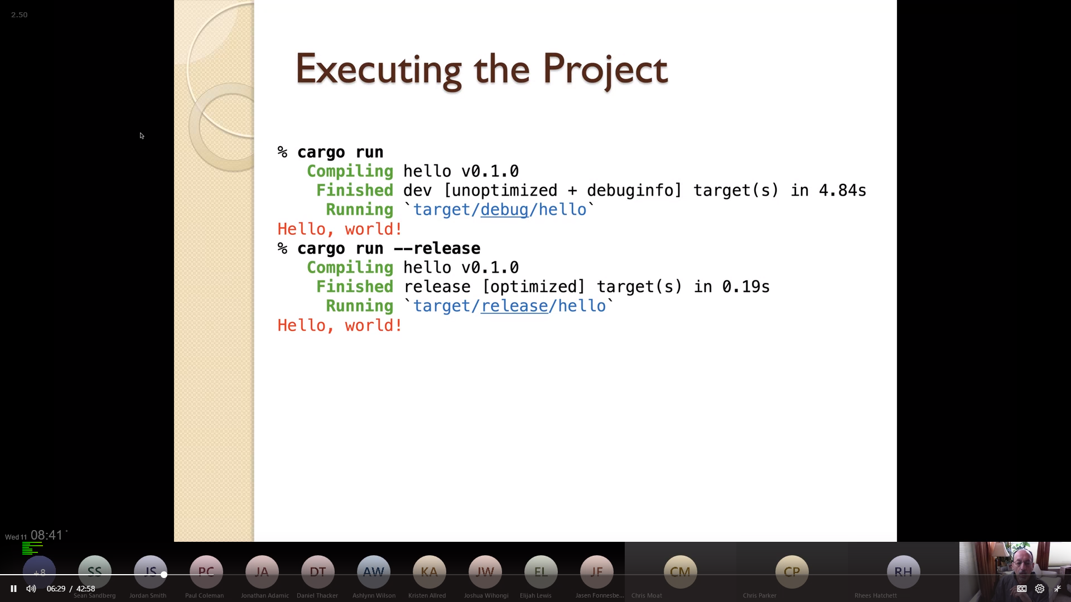

(cd into the project directory)

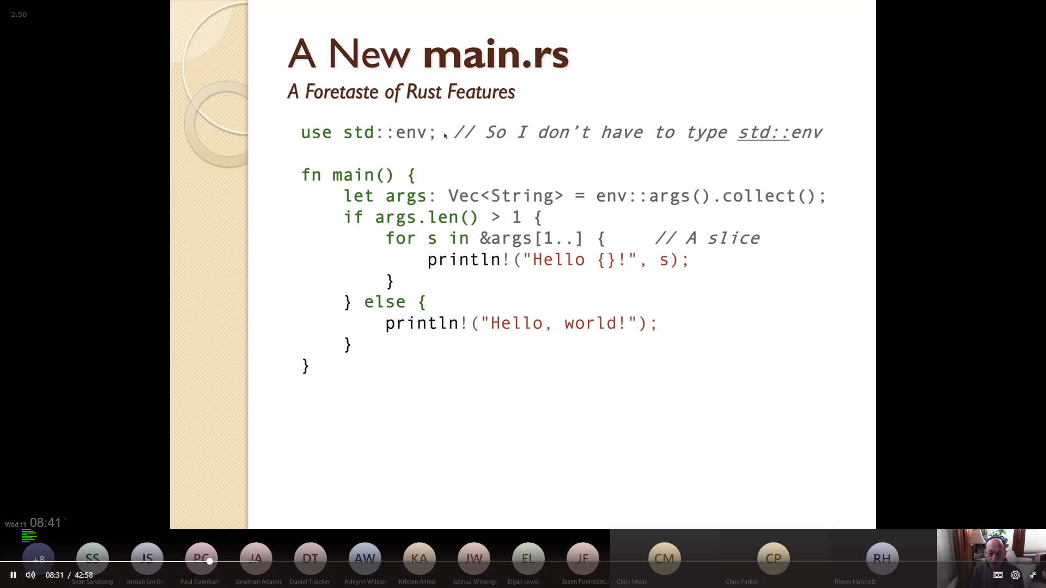

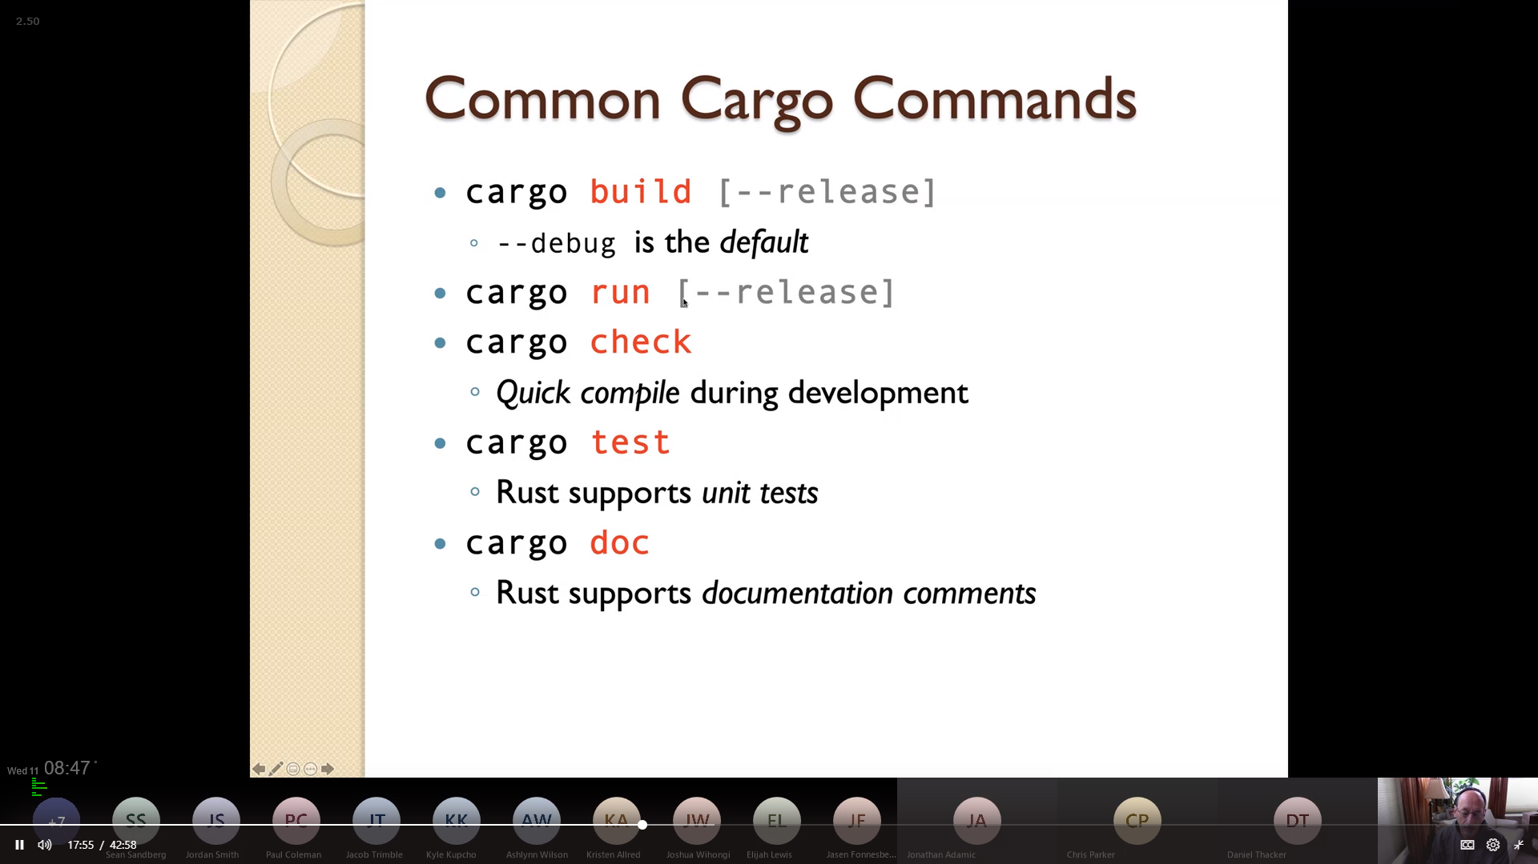

## using random numbers:

see [guess.rs](../Course%20Provided%20Documents/Provided_Code_Samples/guess.rs)

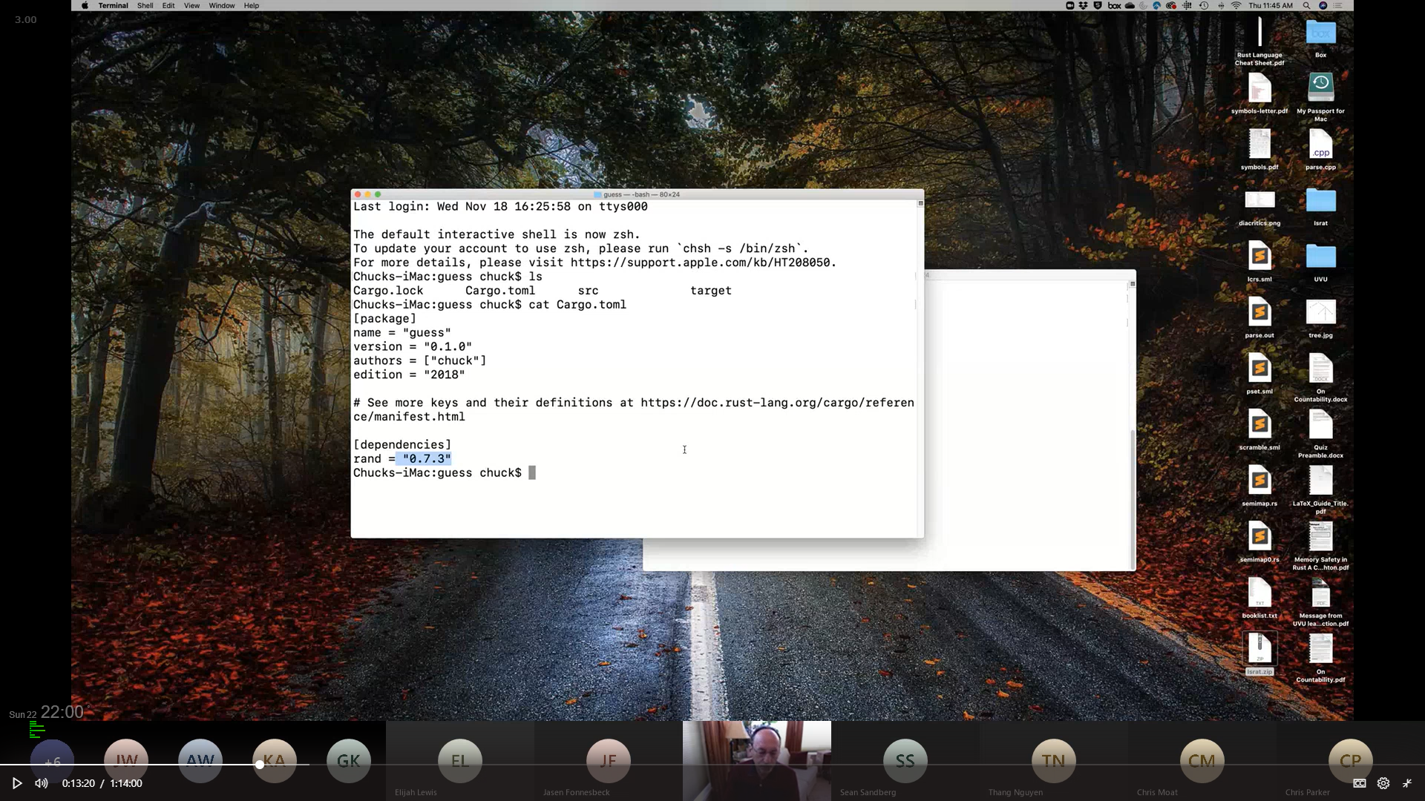

add **rand = <version #>** to the Cargo.toml file

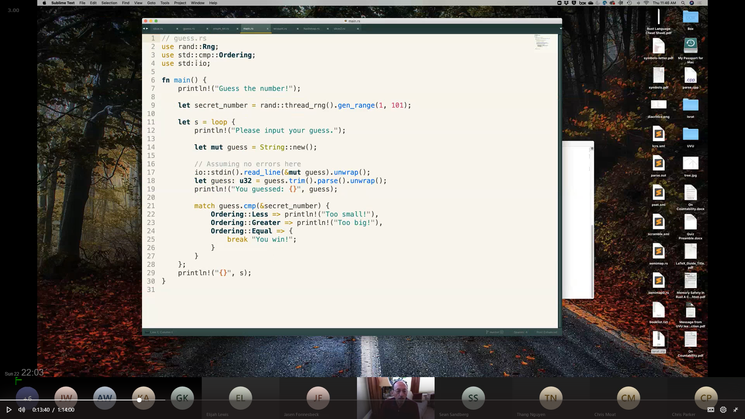

# Data Types (Primitive, Compound & Numeric Literals):

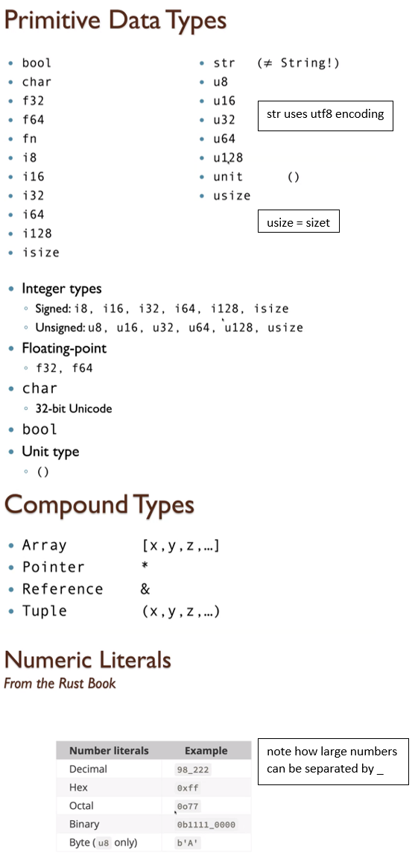

## Shadowing (Static Binding / New Binding):

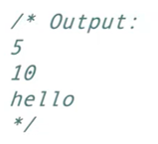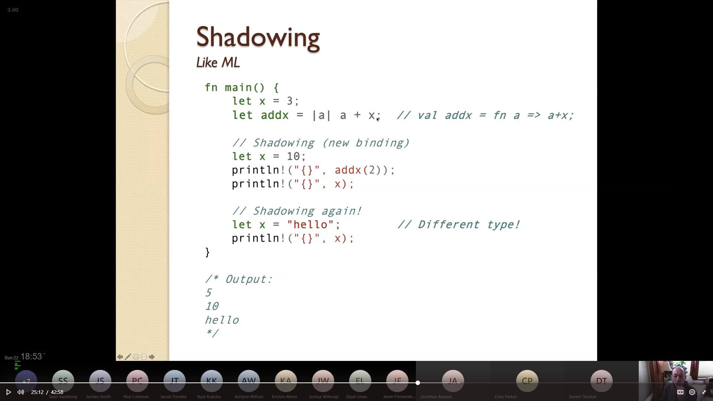

see [Closures](#_Closures_(also_used)

## Using Arrays:

see [array.rs](../Course%20Provided%20Documents/Provided_Code_Samples/array.rs)

## Using Tuples:

see [tuple.rs](../Course%20Provided%20Documents/Provided_Code_Samples/tuple.rs) [fib.rs](../Course%20Provided%20Documents/Provided_Code_Samples/fib.rs) [newton2.rs](../Course%20Provided%20Documents/Provided_Code_Samples/newton2.rs) [tuple_struct.rs](../Course%20Provided%20Documents/Provided_Code_Samples/tuple_struct.rs)

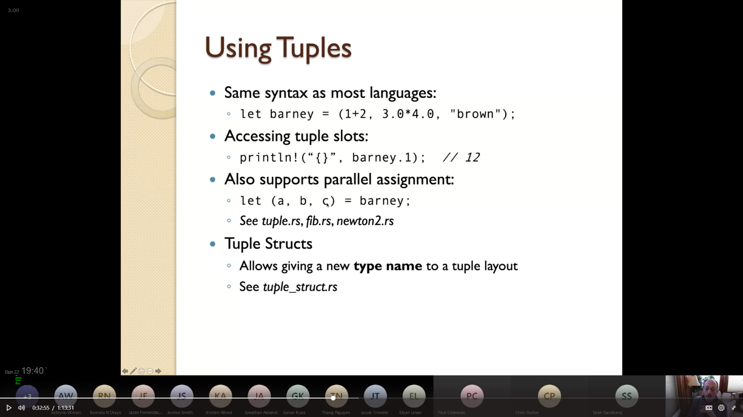

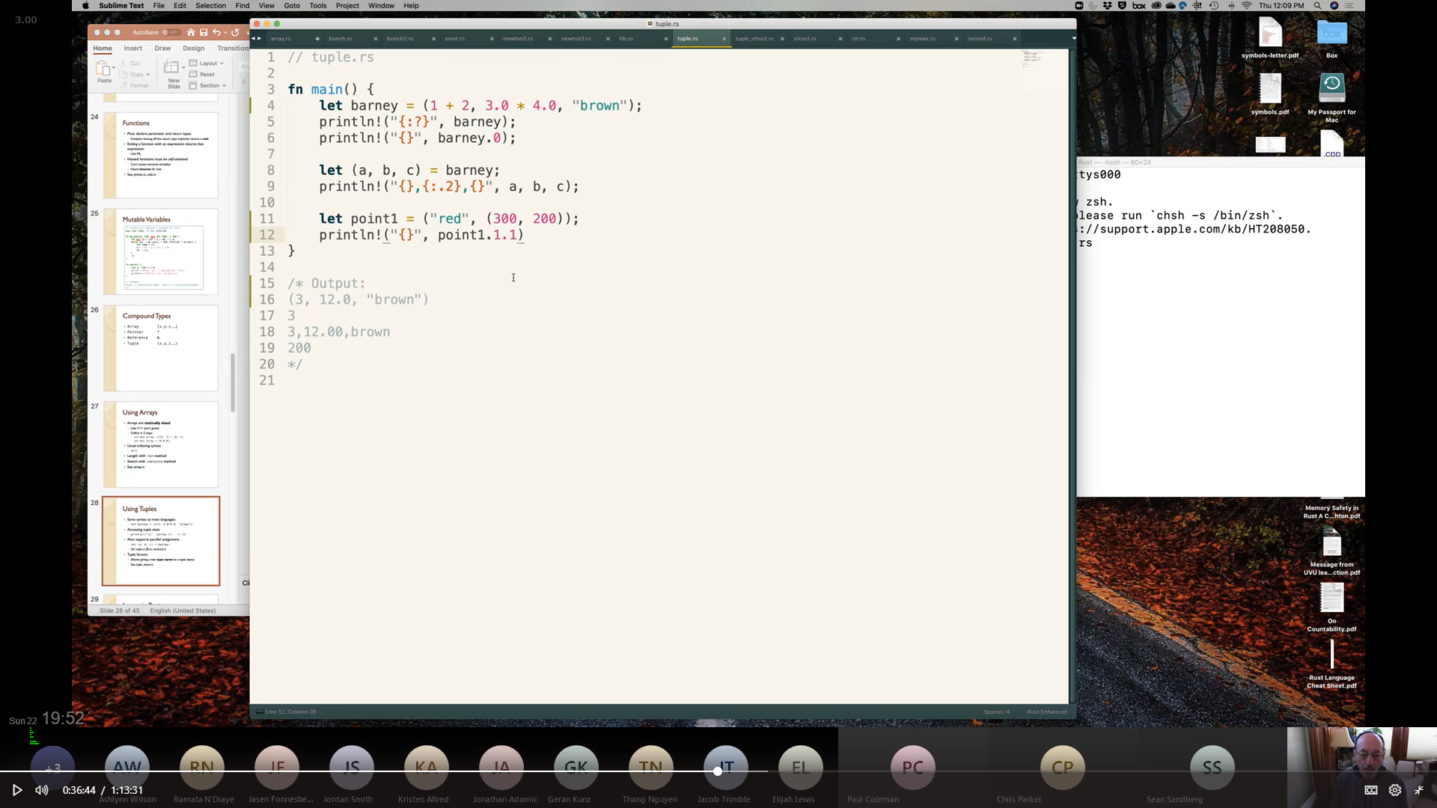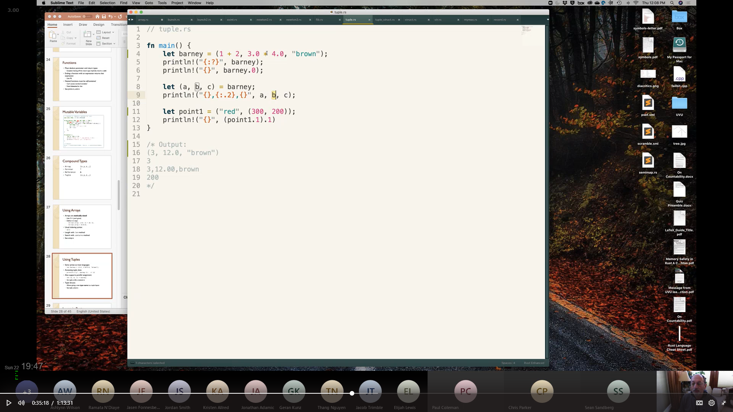

can also by typed :

0 based indexing

tuple index denoted using **.**

2 decimal places

## Defining a new Type & implementing functionality:

see [tuple_struct.rs](../Course%20Provided%20Documents/Provided_Code_Samples/tuple_struct.rs)

see [struct.rs](../Course%20Provided%20Documents/Provided_Code_Samples/struct.rs)

see [exint.rs](../Course%20Provided%20Documents/Provided_Code_Samples/exint.rs)

see [bunch.rs](../Course%20Provided%20Documents/Provided_Code_Samples/bunch.rs) [bunch2.rs](../Course%20Provided%20Documents/Provided_Code_Samples/bunch2.rs)

see [mymax.rs](../Course%20Provided%20Documents/Provided_Code_Samples/mymax.rs)

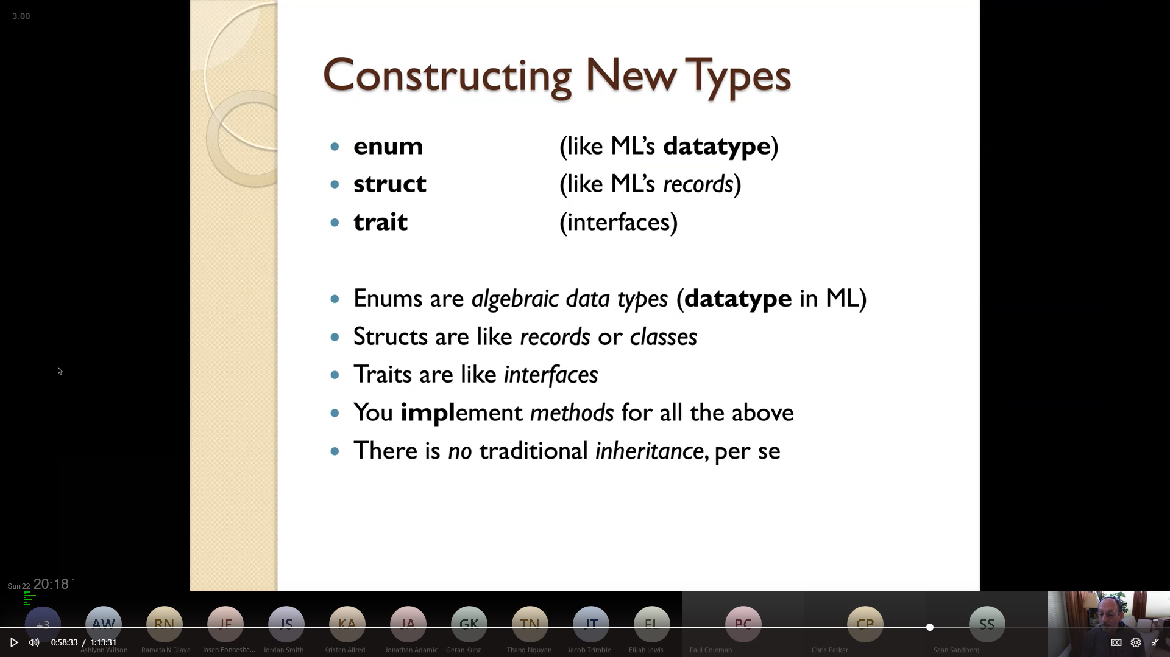

### Type Construction Examples:

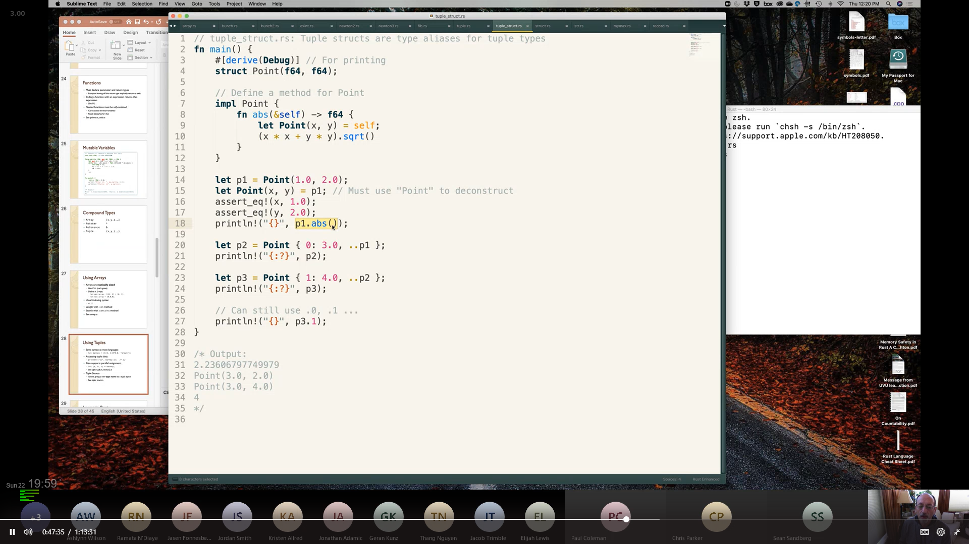

allows the new type to use the {:?} debug operator

pattern matching

call the function normally

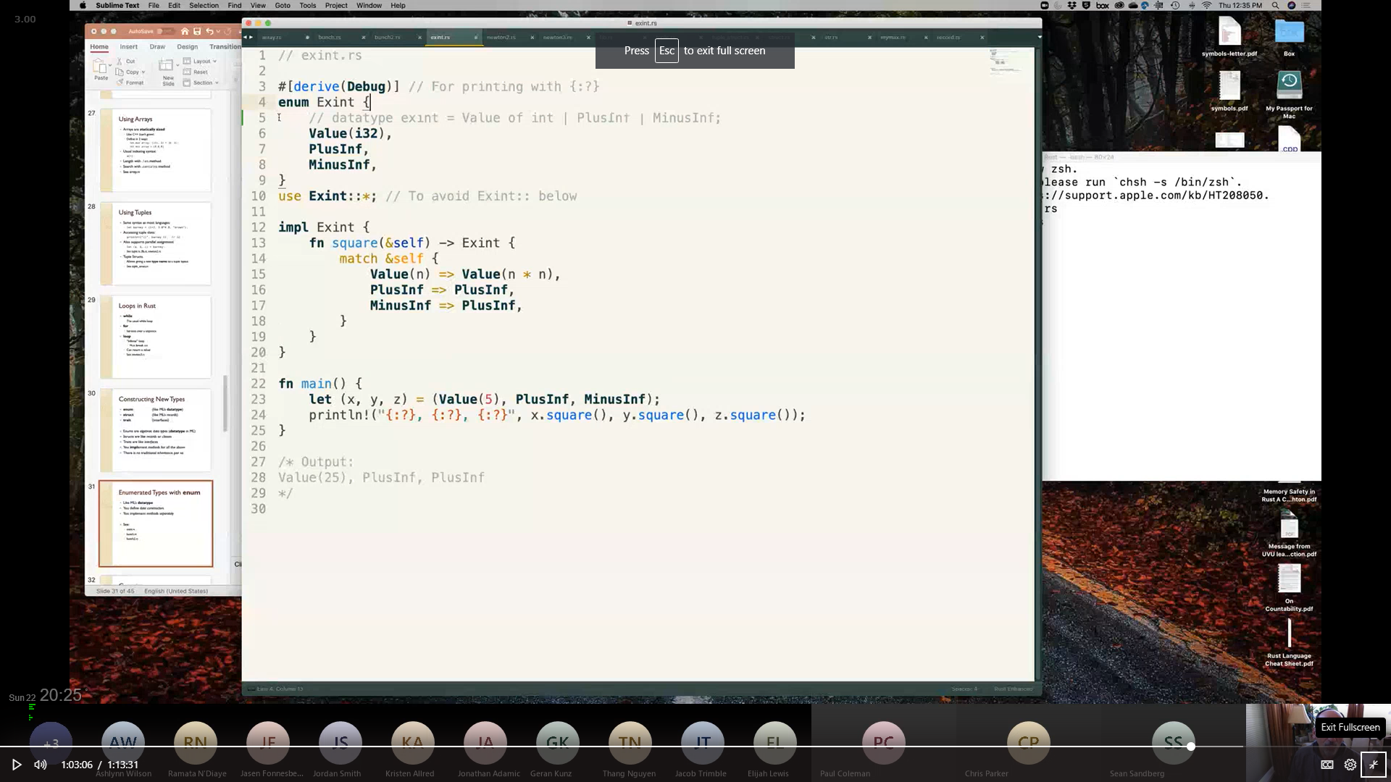

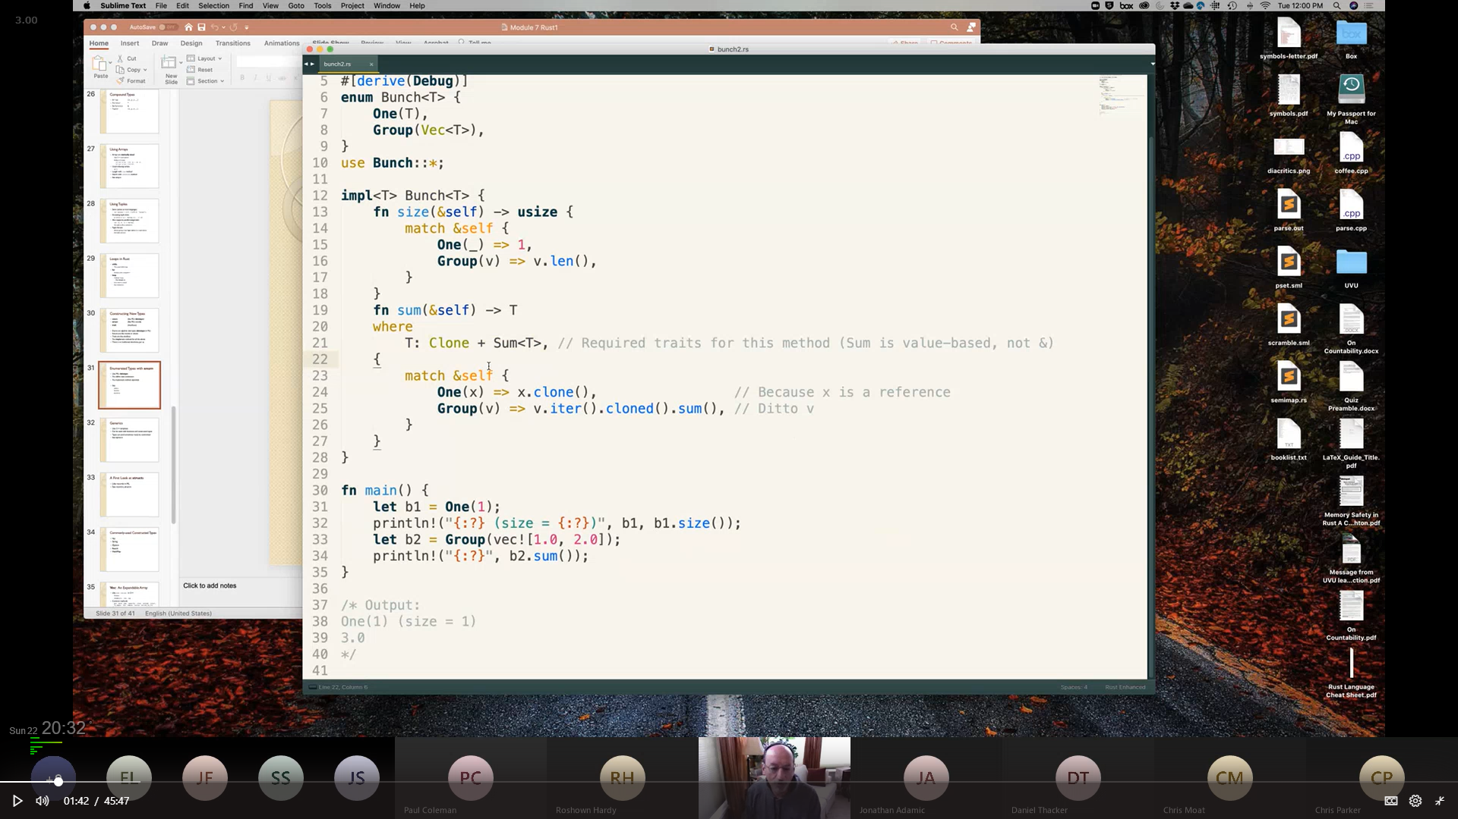

type constraints

impl <T> --> template<typname T>

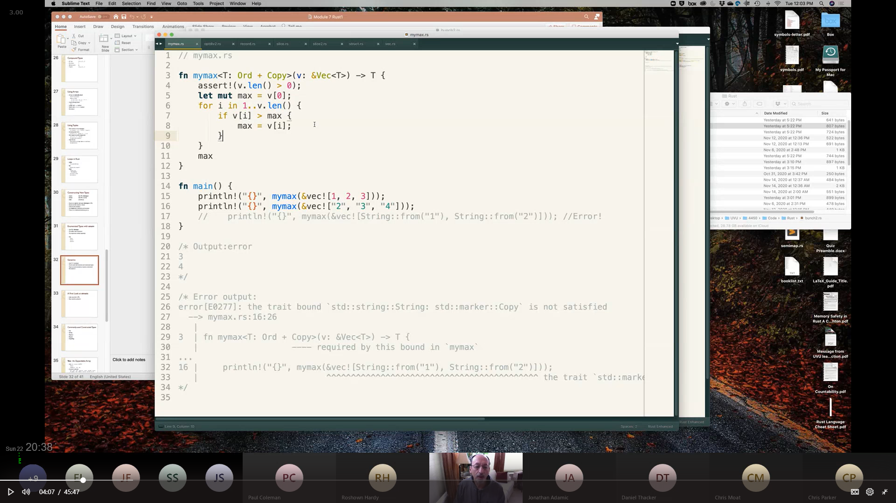

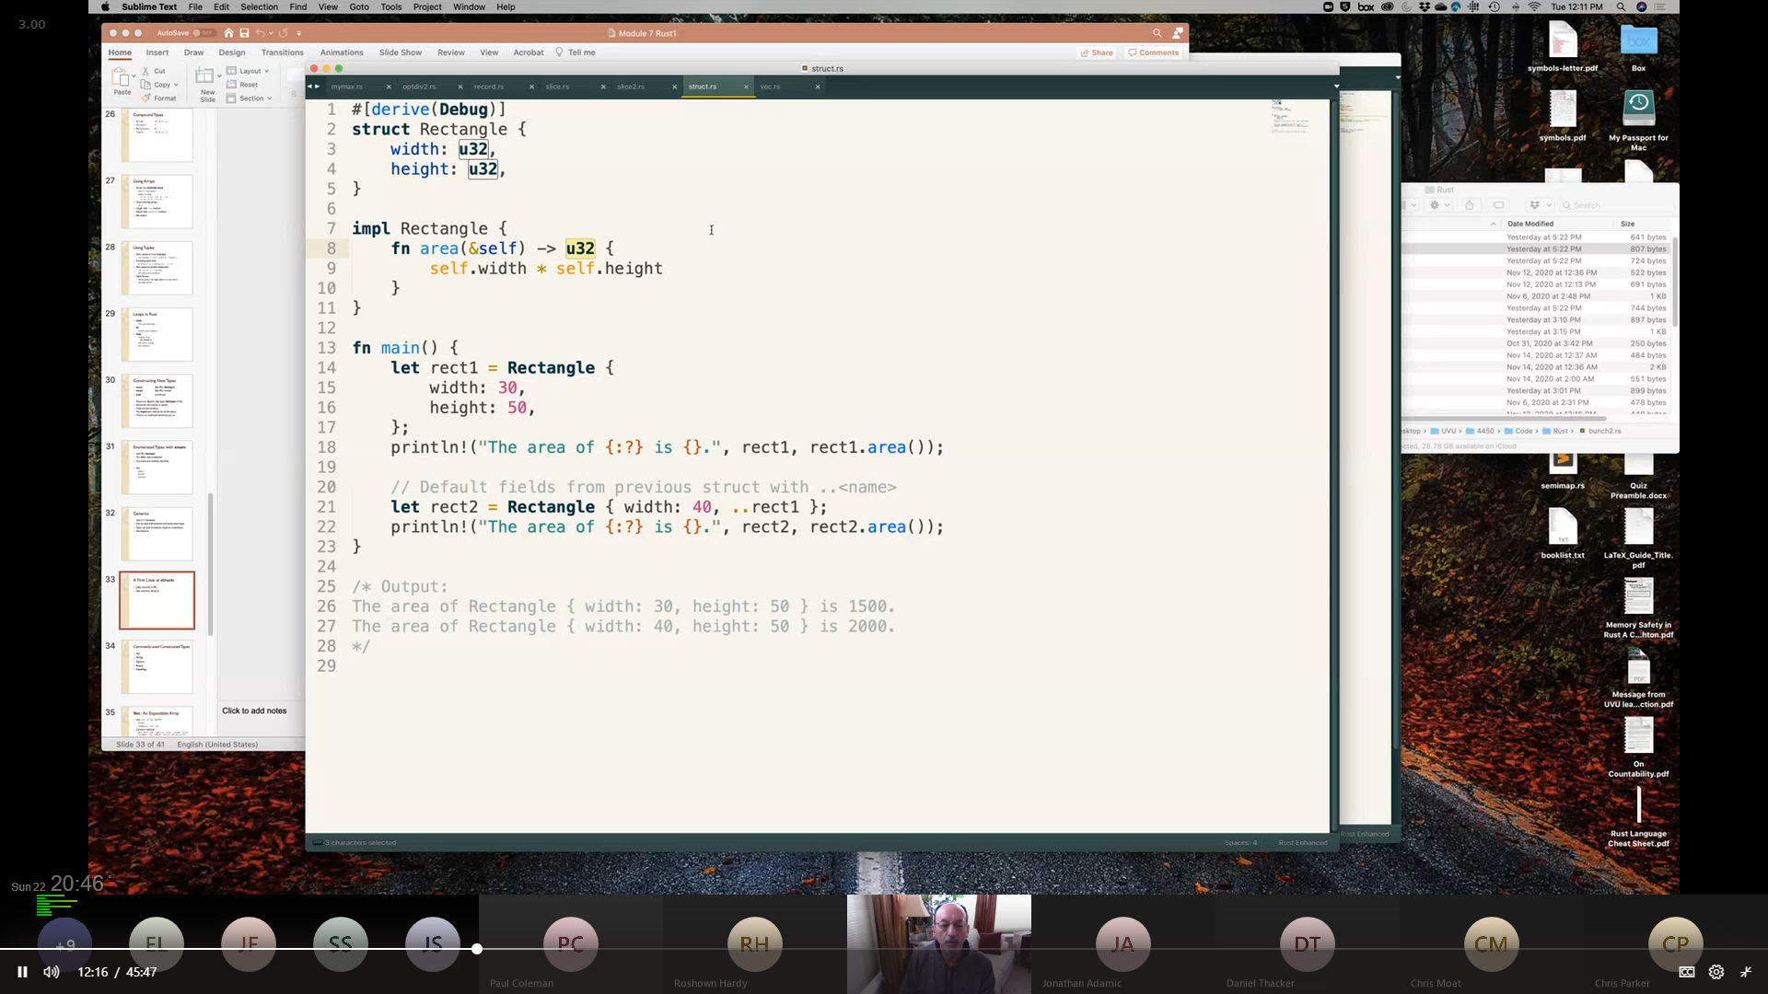

## Vec: An Expandable Array:

see [vec.rs](../Course%20Provided%20Documents/Provided_Code_Samples/vec.rs)

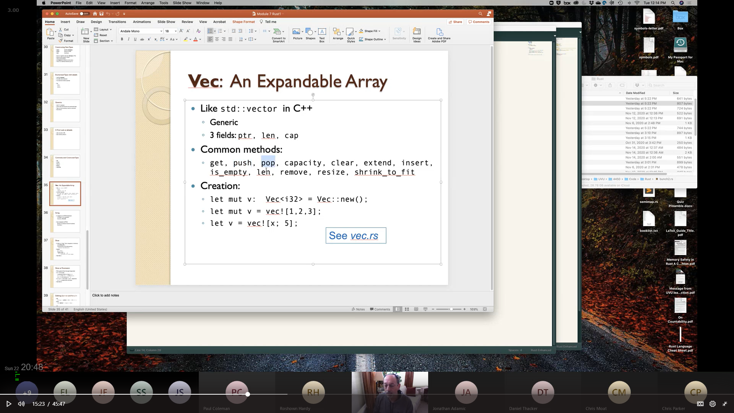

## String:

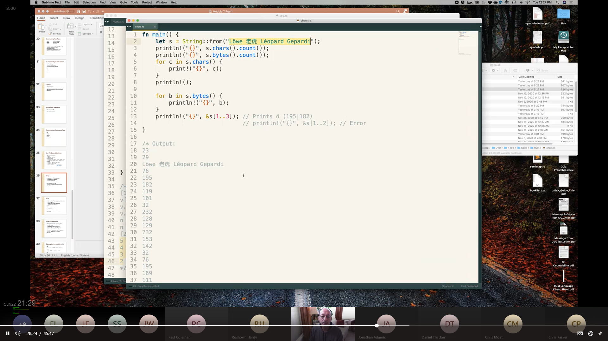see [chars.rs](../Course%20Provided%20Documents/Provided_Code_Samples/chars.rs)

see [move2.rs](../Course%20Provided%20Documents/Provided_Code_Samples/move2.rs)

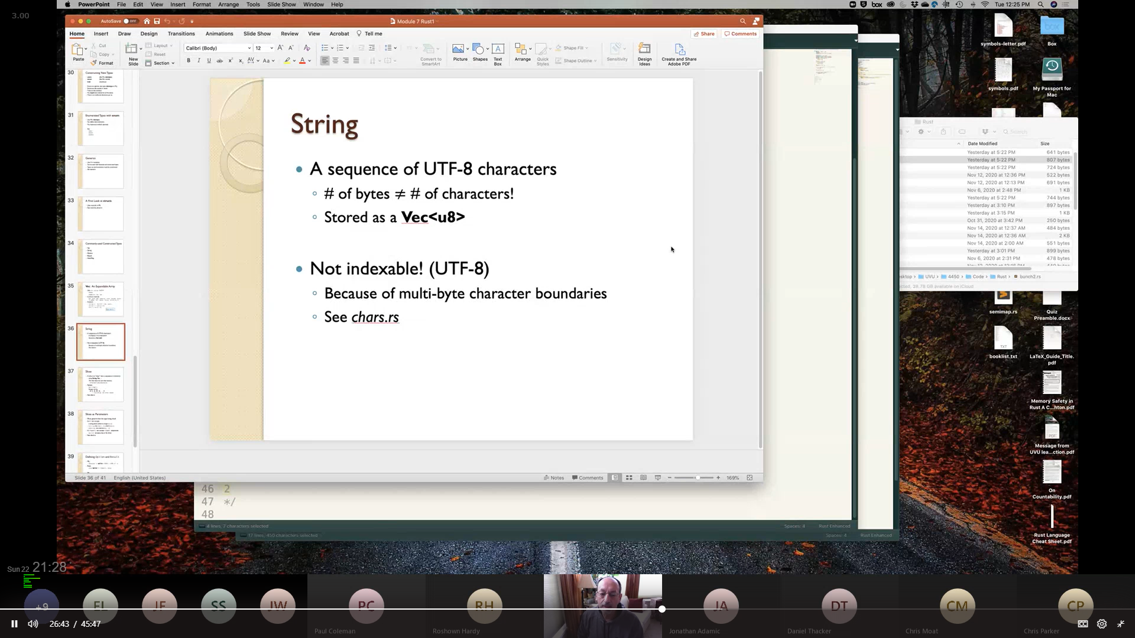

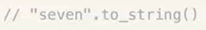

i.e. han characters (chinese, japanese, korean) are 3 bytes long

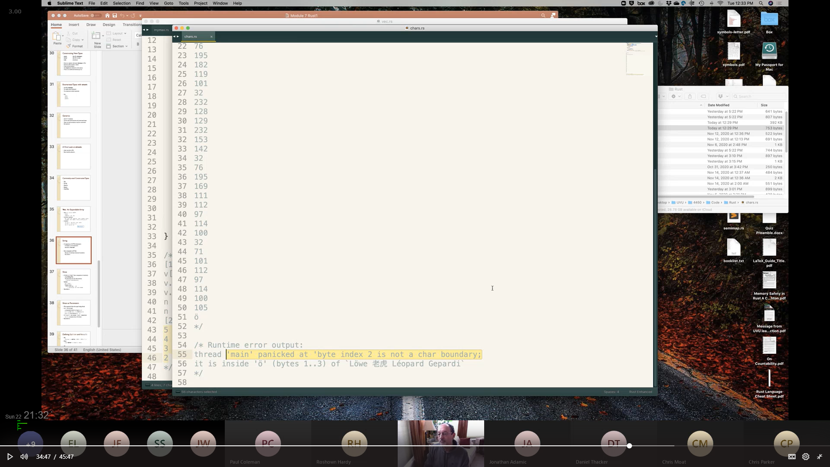

## Defining Option and Result:

see [optdiv2.rs](../Course%20Provided%20Documents/Provided_Code_Samples/optdiv2.rs)

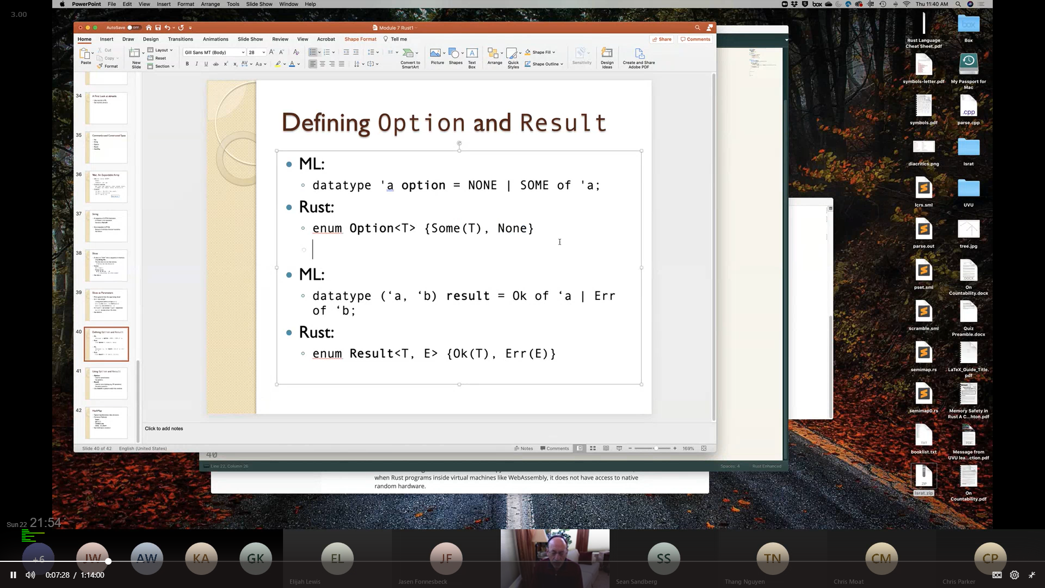

### using Result:

#### No Error Handling:

unwrap() returns the result value stored in Ok



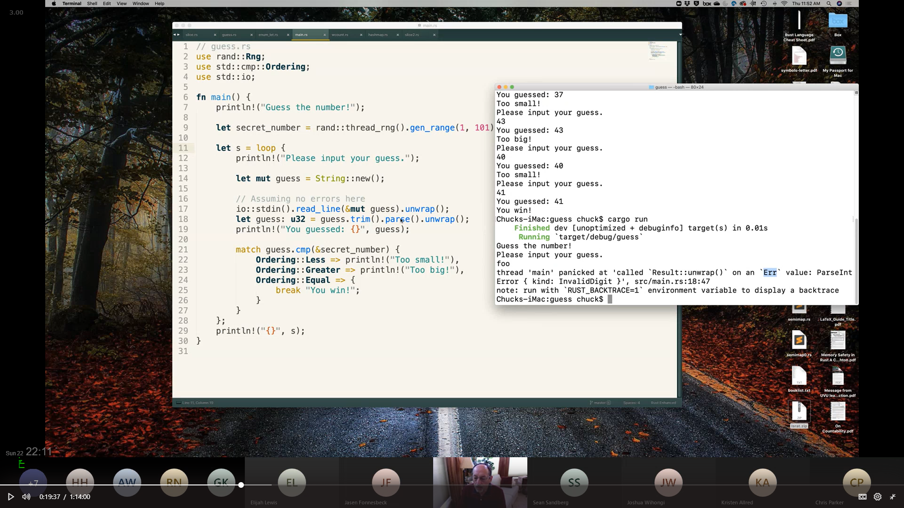

#### Error Handling using match:

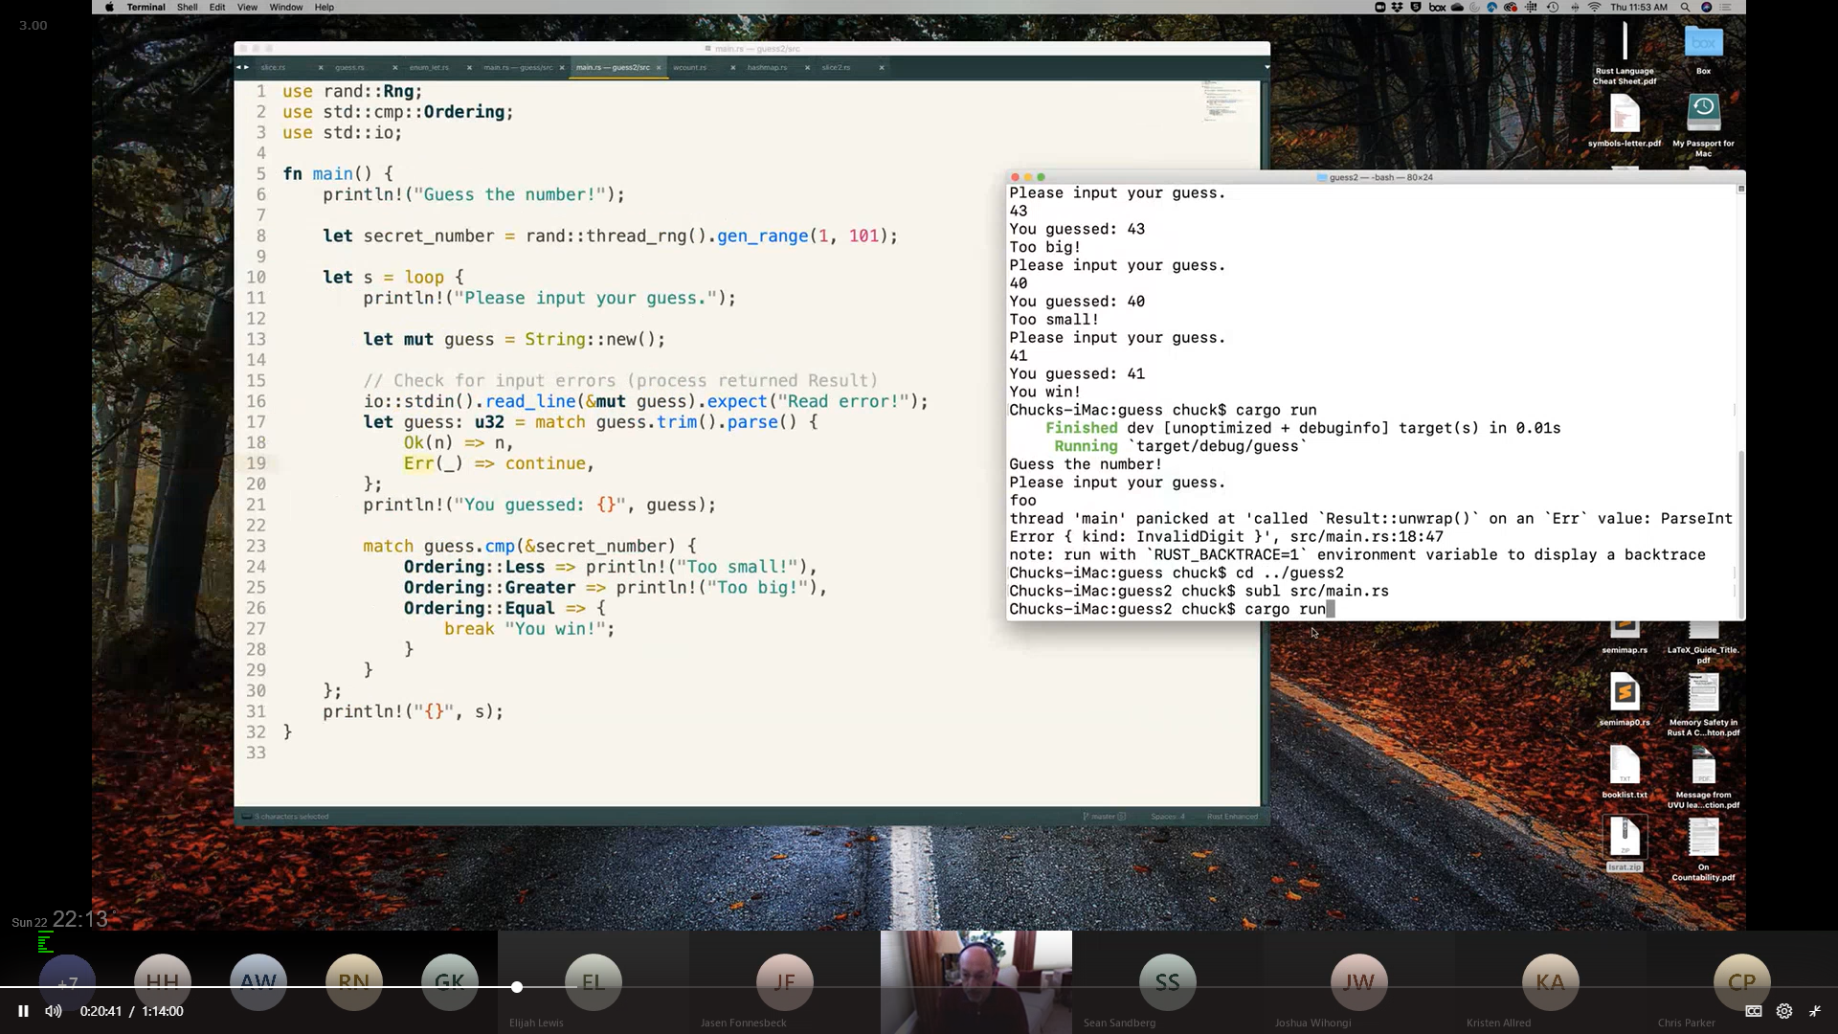

set error message using expect("error msg")

# Slices & Ranges:

see [slice.rs](../Course%20Provided%20Documents/Provided_Code_Samples/slice.rs) [slice2.rs](../Course%20Provided%20Documents/Provided_Code_Samples/slice2.rs)

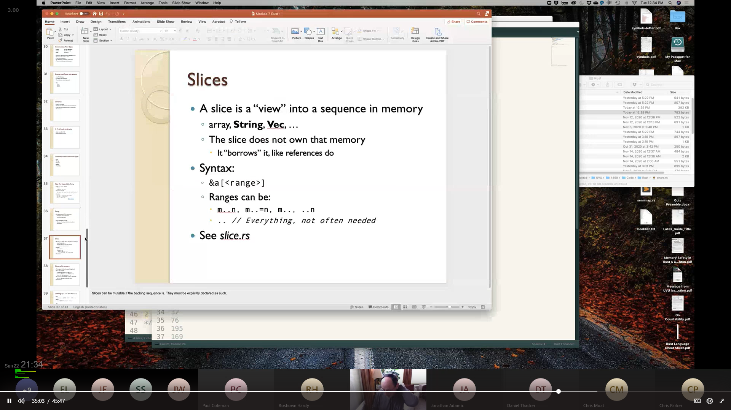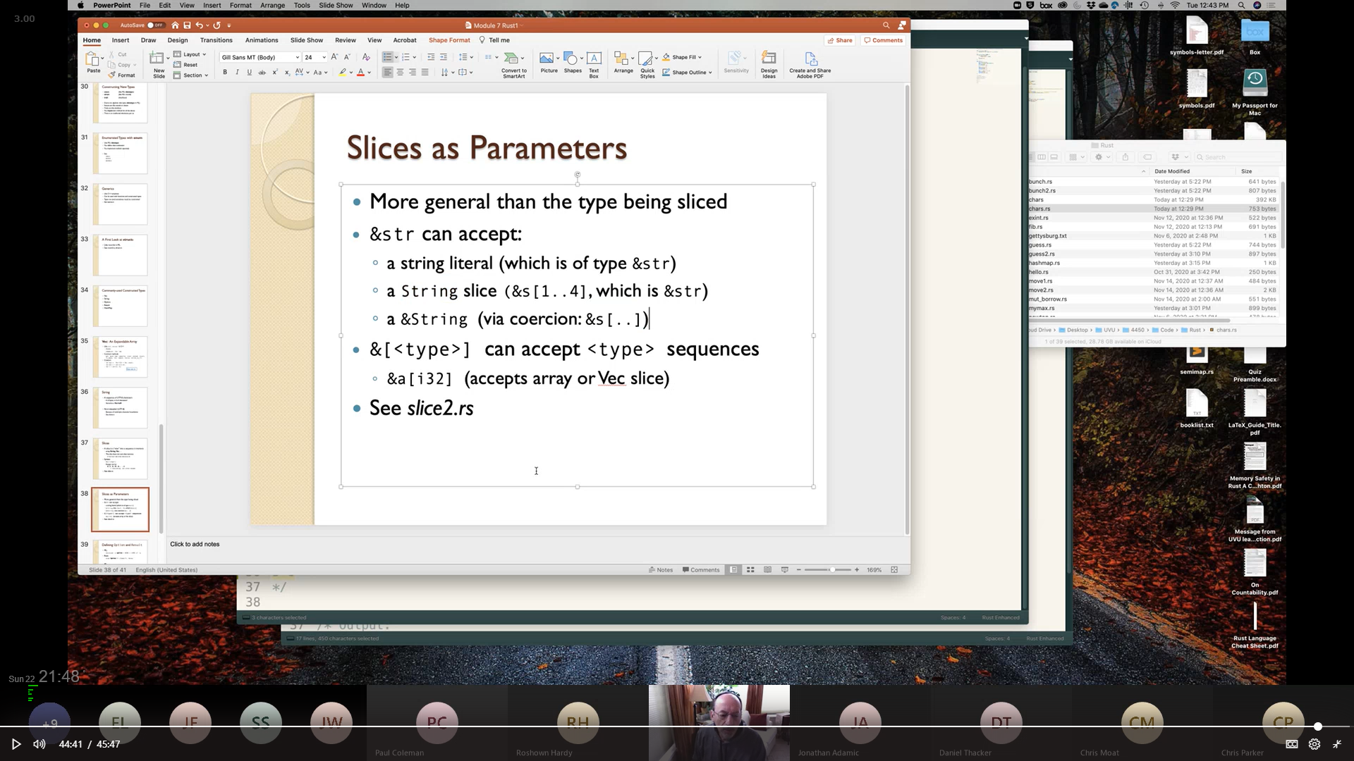

# HashMap:

see [hashmap.rs](../Course%20Provided%20Documents/Provided_Code_Samples/hashmap.rs)

see [wcount.rs](../Course%20Provided%20Documents/Provided_Code_Samples/wcount.rs) [wcount2.rs](../Course%20Provided%20Documents/Provided_Code_Samples/wcount2.rs)

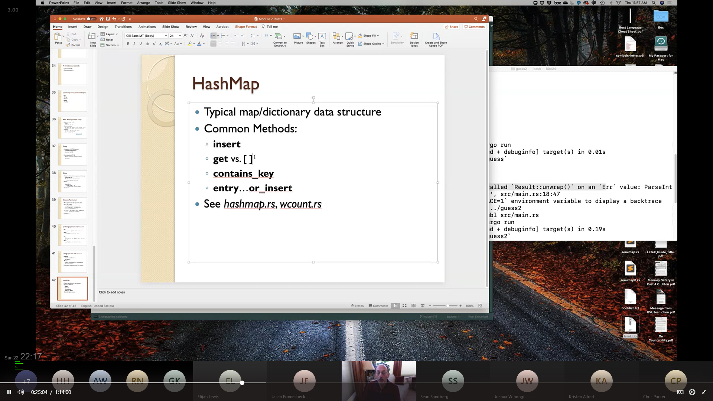

**get** returns an **Option**

**insert** will **overwrite**

# If let / While let:

see [enum_let.rs](../Course%20Provided%20Documents/Provided_Code_Samples/enum_let.rs)

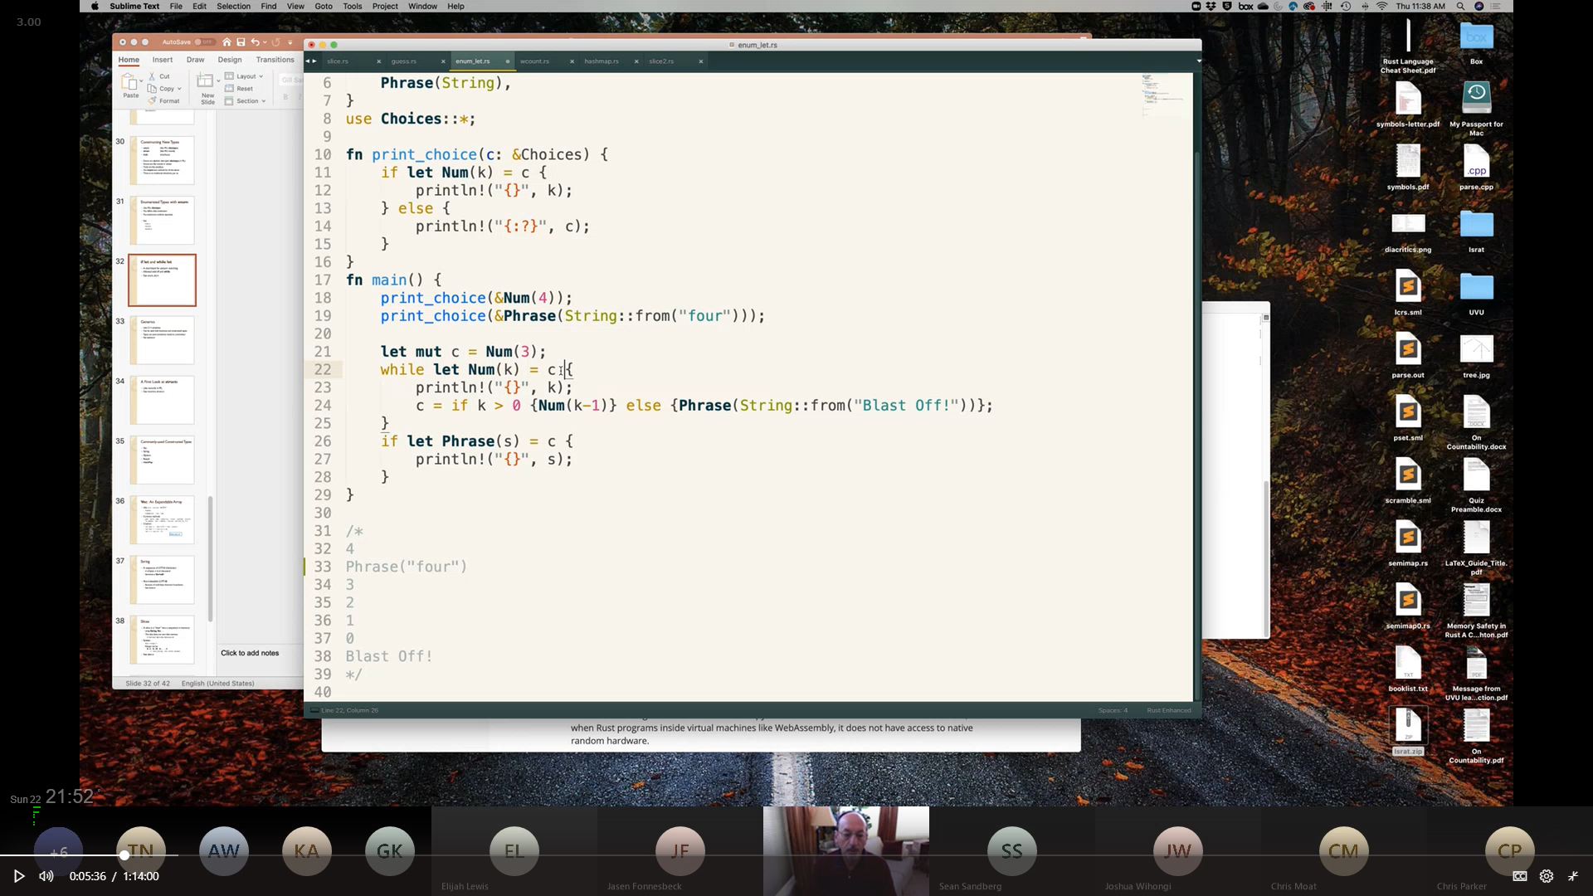

# Loops in Rust:

see [newton3.rs](../Course%20Provided%20Documents/Provided_Code_Samples/newton3.rs)

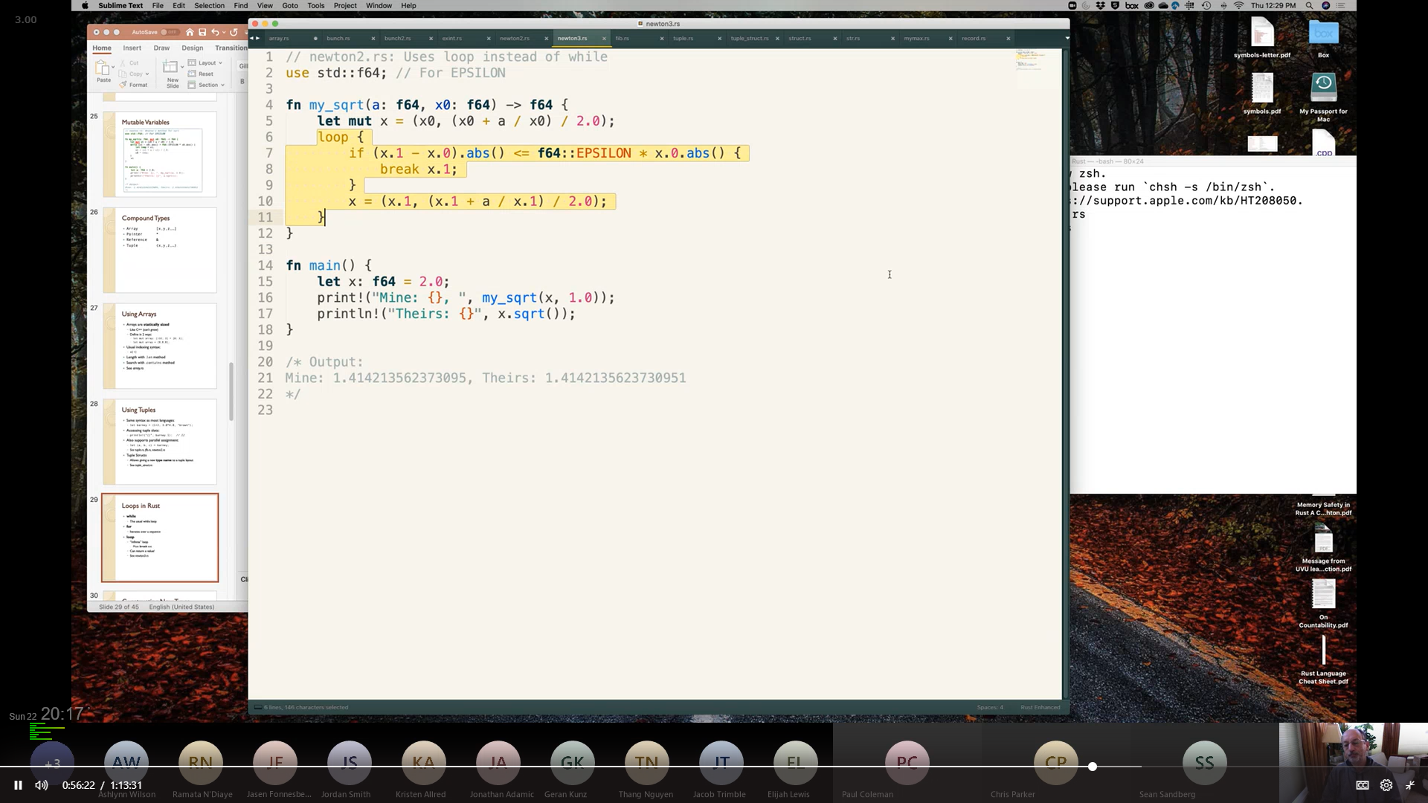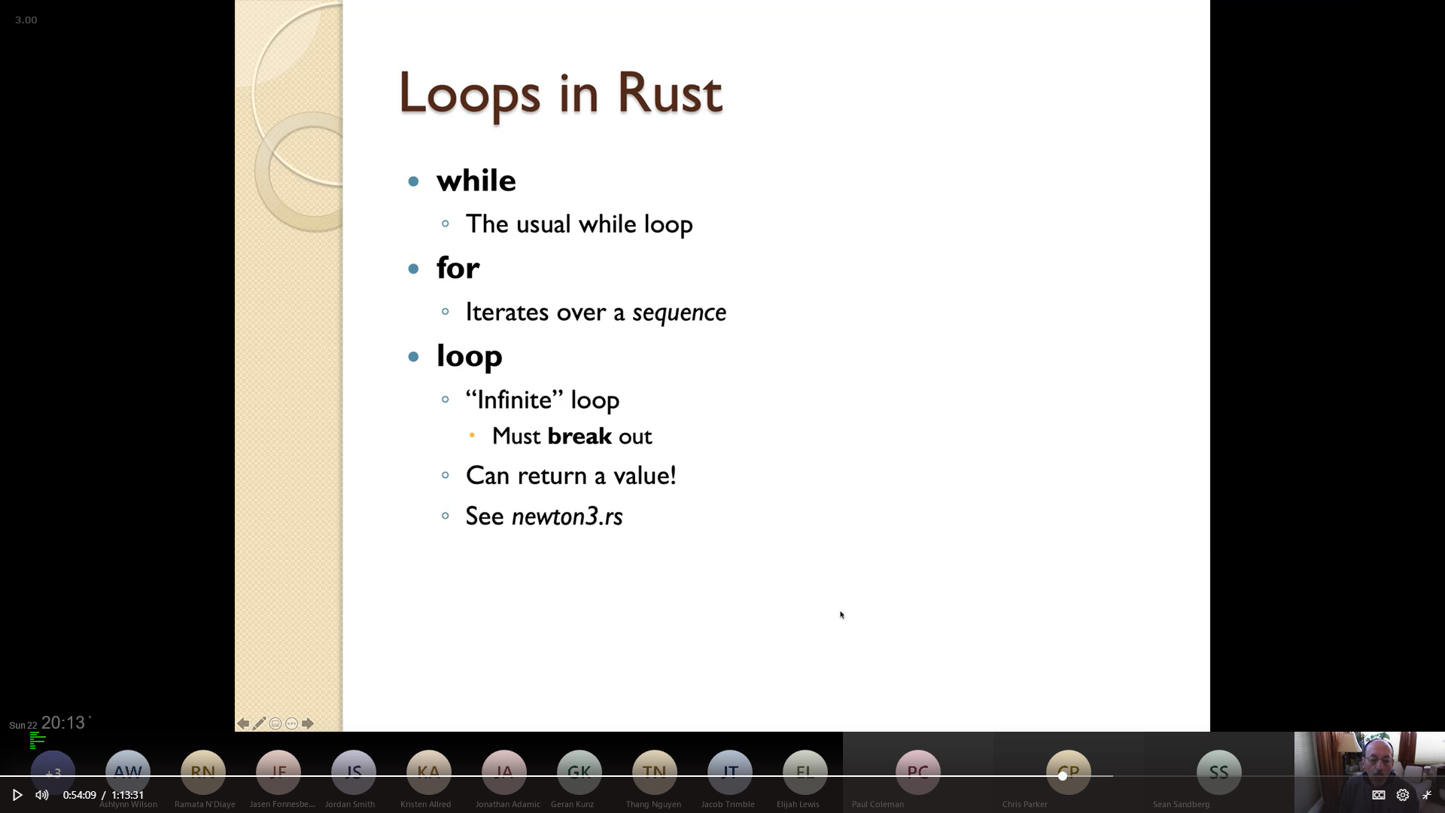

## How For Loops Work:

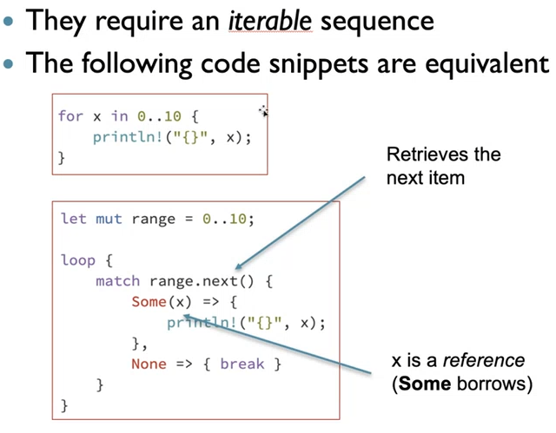

# Functions:

## Returning a value from a function:

see [prime.rs](../Course%20Provided%20Documents/Provided_Code_Samples/prime.rs) [optdiv.rs](../Course%20Provided%20Documents/Provided_Code_Samples/optdiv.rs) [optdiv2.rs](../Course%20Provided%20Documents/Provided_Code_Samples/optdiv2.rs)

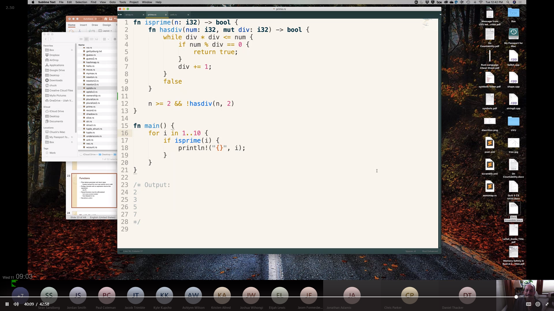

Return values can be C++ style or ML style

ML style return values

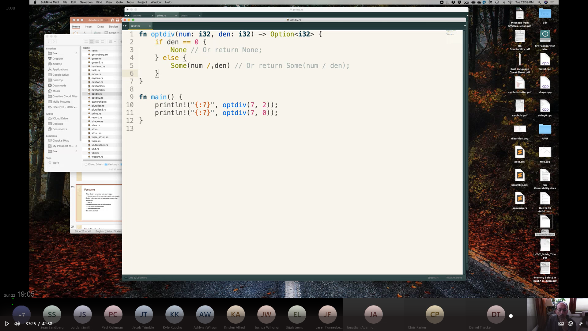

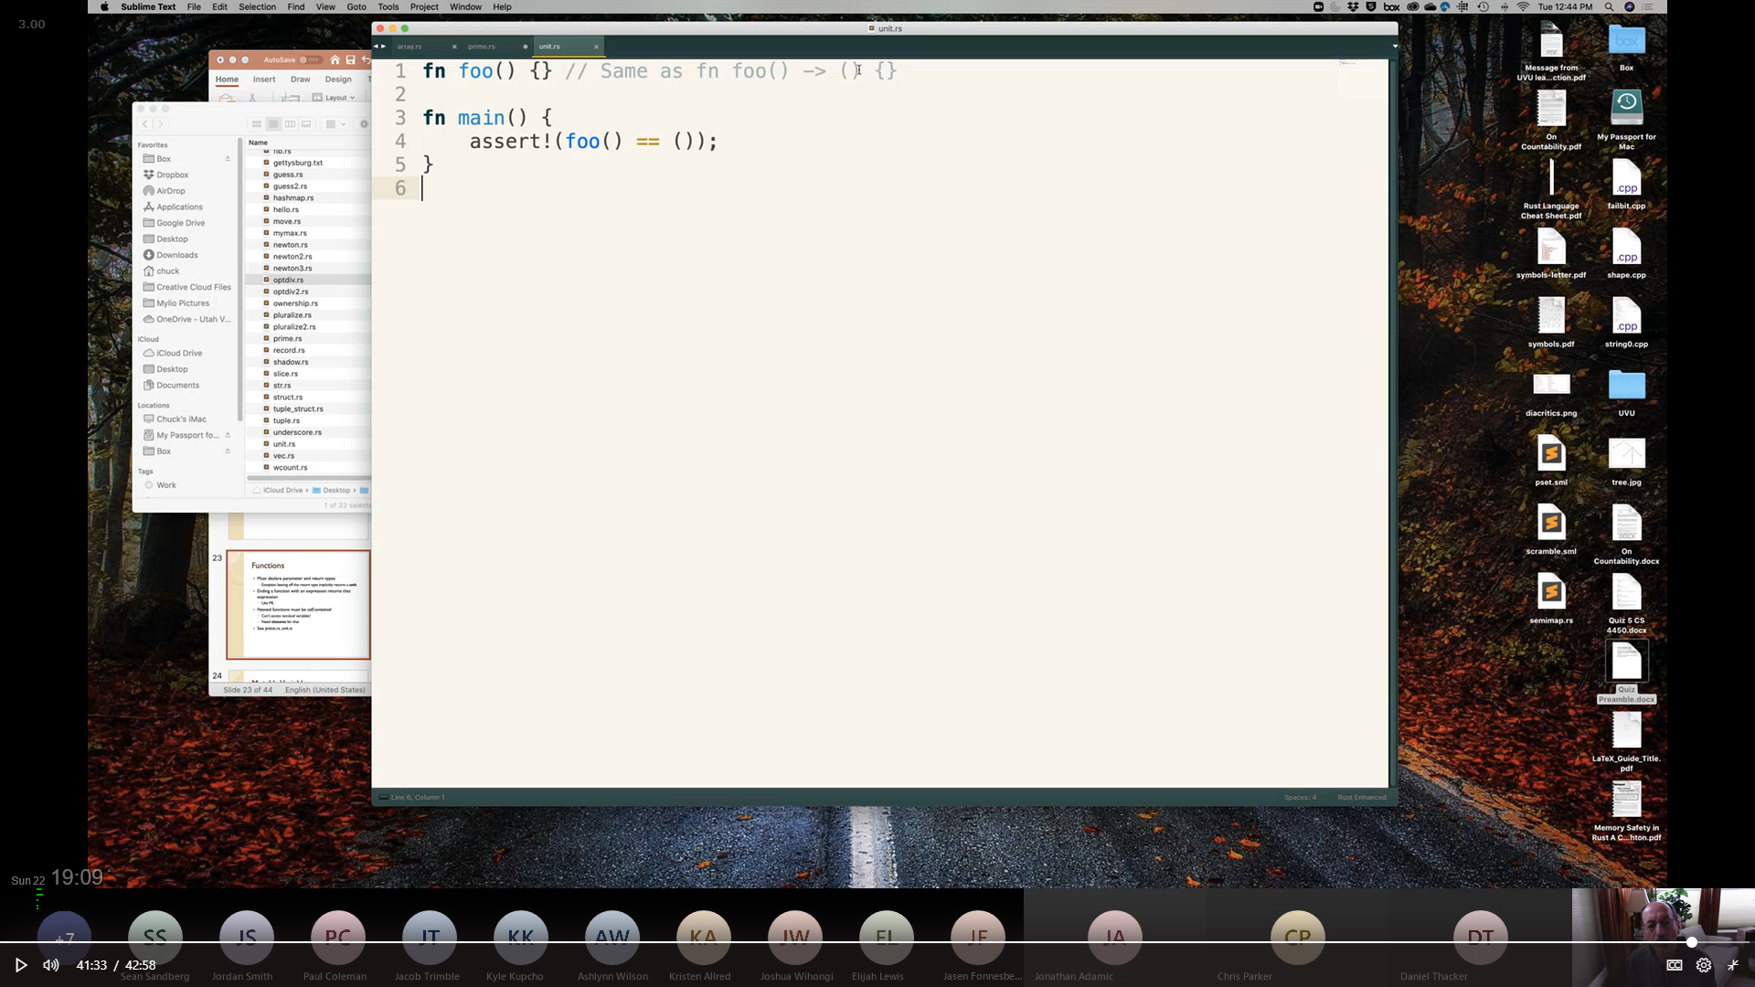

Functions that don’t return anything, return a **UNIT ( )**

## Function Composition:

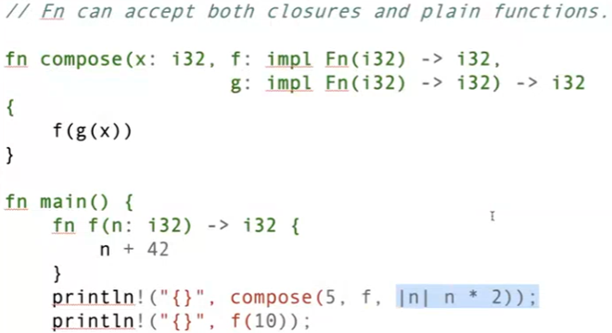

see [Closures](#_Closures_(also_used)

# Mutable Variables:

variables are naturally statically bound and immutable.

use the **mut** keyword to designate a mutable variable

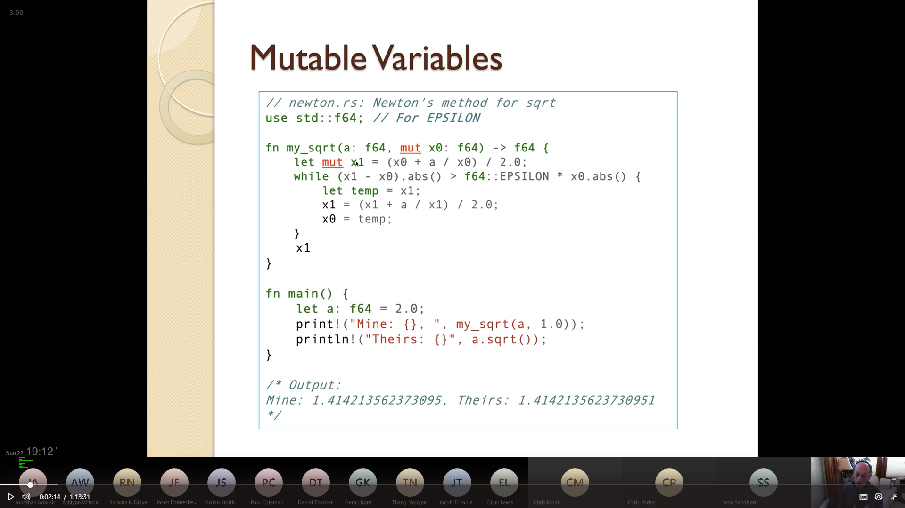

Note that **f64** is both a **type** & a **namespace**

Note the keyword **mut** before the variable name.

# Ownership:

## What is Ownership?

2 things cannot OWN the same value

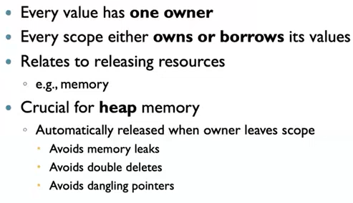

An example of what it means to "Own" something :

When something goes out of scope, the destructor is called on everything it "owns"



no Aliasing,

(because that would give us double deletes)

## Passing Arguments:

see [move2.rs](../Course%20Provided%20Documents/Provided_Code_Samples/move2.rs)

### By Value:

implements Copy Trait

### By Move:

implements Drop trait

Items which implement the Drop trait can be forced to act like Copy trait by using

<<variable>>.clone()

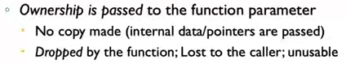

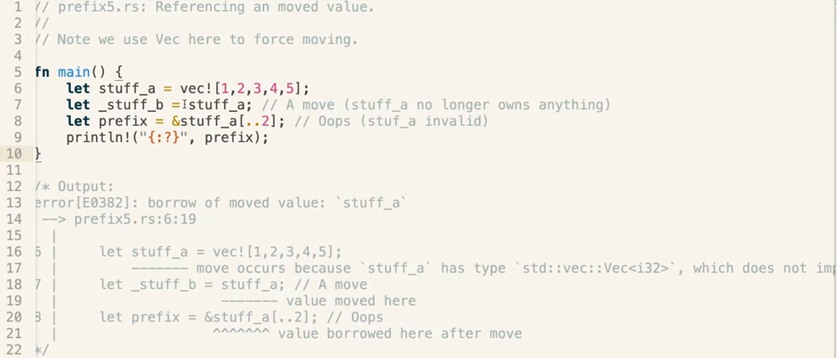

### By Reference – ("borrowing") :

the function borrows the value; *no ownership*

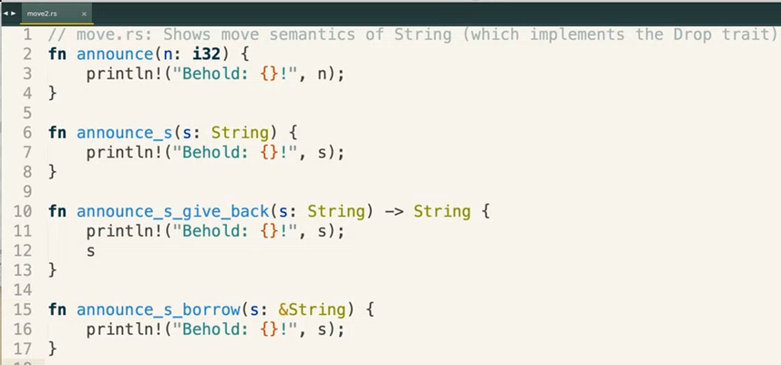



the value passed into s will be Moved, but the value return by the function will also be Moved,

so the variable which originally owned the value Moved to (and currently owned by) 's', now owns the value returned by the function,

and the value passed into 's' will be destroyed when the function goes out of scope, unless it's the same value returned by the function

String implements the Drop trait, so the value passed into s will be Moved, not Copied

i32 implements Copy trait, so the value is Copied

the value passed into 's' is Borrowed as a reference, ( Not Copied or Moved )

# Borrowing / References:

## Borrowing rules:

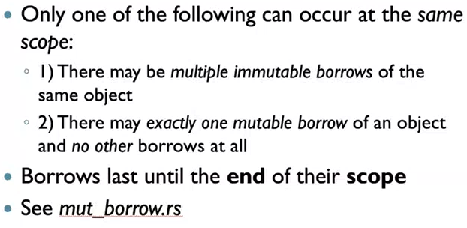

### Lifetime:

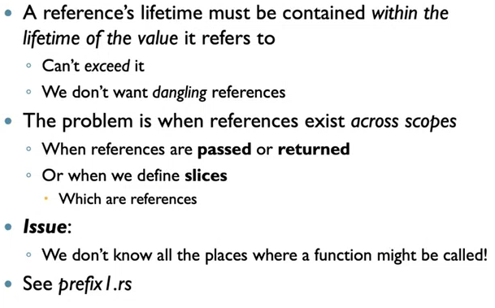

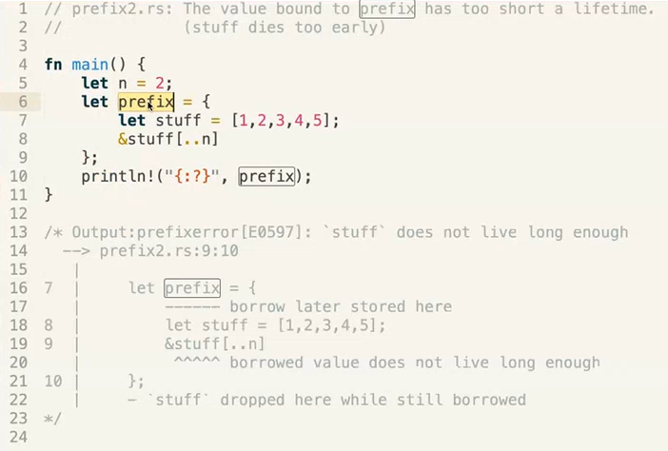

returning a reference to a variable that no longer exists

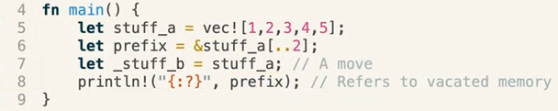

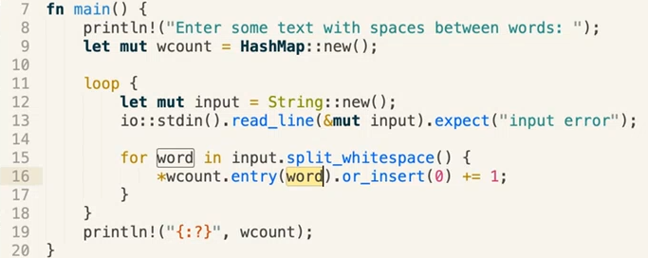

'word' is a reference to a splice from 'input', which is destroyed upon exiting the loop.

use String::from(word)

#### Declaring Lifetime Parameters Using ' :

see [honorific.rs](../Course%20Provided%20Documents/Provided_Code_Samples/honorific.rs) [honorific2.rs](../Course%20Provided%20Documents/Provided_Code_Samples/honorific2.rs) [honorific3.rs](../Course%20Provided%20Documents/Provided_Code_Samples/honorific3.rs) [honorific4.rs](../Course%20Provided%20Documents/Provided_Code_Samples/honorific4.rs)

the 'a notes that all parameter and return values all have the same lifetime (a.k.a the same scope?)



### mut_borrow.rs

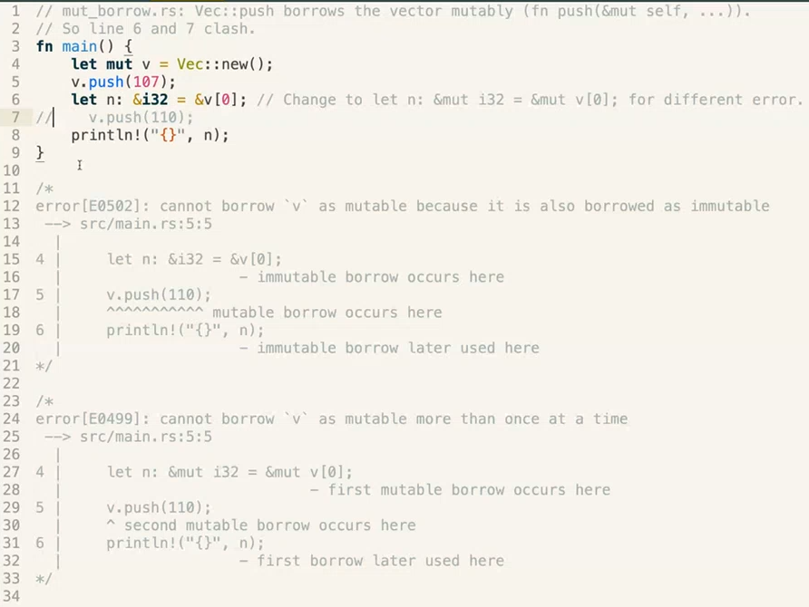

### multiple references?

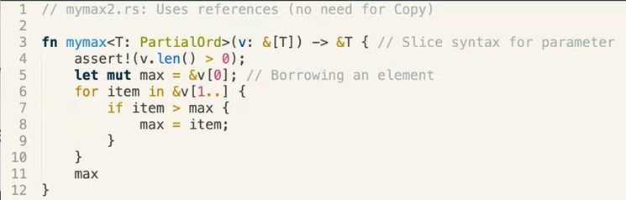

is max a mutable reference to an immutable item? In other words, when we assign max, do we change the reference that max is pointing to, or do we change the value in the location that max points to?

note that the Iterator reference 'item' is in a new scope

# Traits, Generics & Lifetimes:

## Traits:

see [mymax.rs](../Course%20Provided%20Documents/Provided_Code_Samples/mymax.rs)  & [mymax2.rs](../Course%20Provided%20Documents/Provided_Code_Samples/mymax2.rs)

see [bunch2.rs](../Course%20Provided%20Documents/Provided_Code_Samples/bunch2.rs)

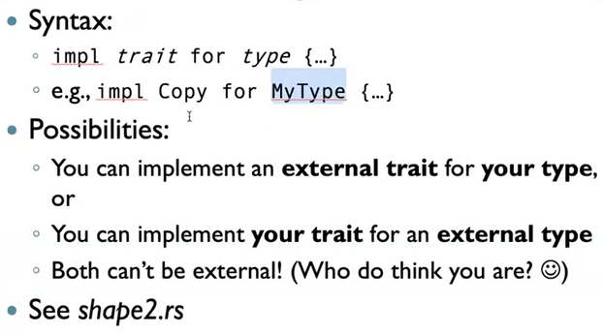

"You can't re-implement something that is none of your business to do" – Professor Chuck Allison

see [float.rs](../Course%20Provided%20Documents/Provided_Code_Samples/float.rs)

see [shape2.rs](../Course%20Provided%20Documents/Provided_Code_Samples/shape2.rs)

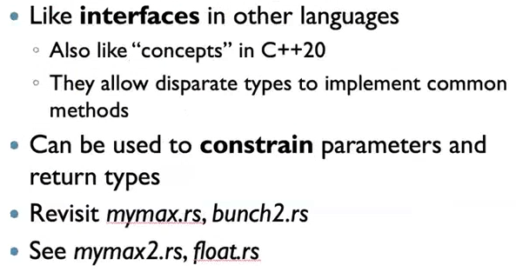

### Implementing Traits Example:

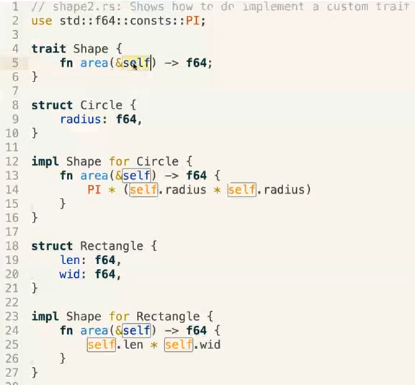

'impl' is resolved at compile time



### Traits & Dynamic Dispatch:

see [shape3.rs](../Course%20Provided%20Documents/Provided_Code_Samples/shape3.rs)

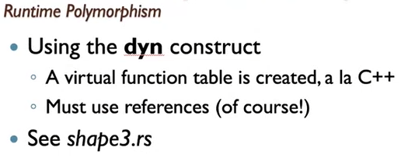

'dyn' is resolved at runtime

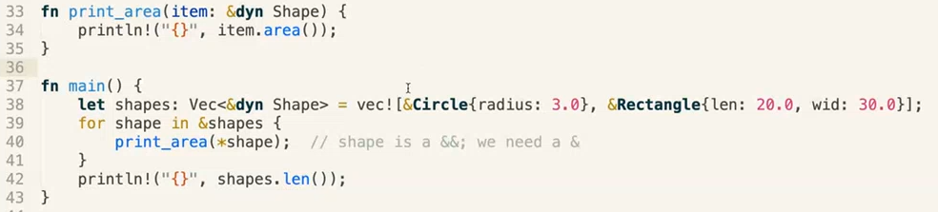

### Box<T>:

see [shape4.rs](../Course%20Provided%20Documents/Provided_Code_Samples/shape4.rs)

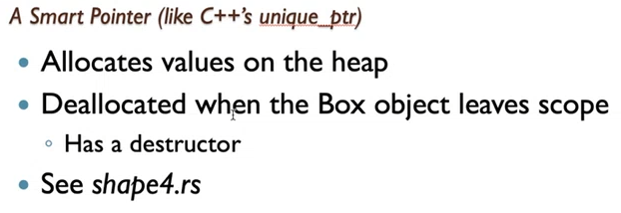

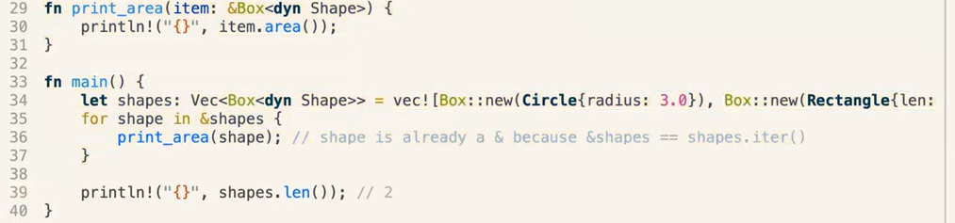

#### ML Style Implementation:

see [cons.rs](../Course%20Provided%20Documents/Provided_Code_Samples/cons.rs)

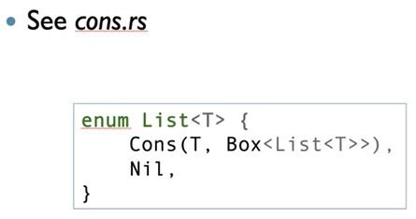

## Copy vs Drop Traits:

see [move1.rs](../Course%20Provided%20Documents/Provided_Code_Samples/move1.rs)

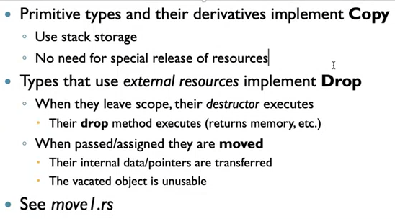

# Closures (also used to implement Lambdas):

see [add_x_to_all.rs](../Course%20Provided%20Documents/Provided_Code_Samples/add_x_to_all.rs) [add_x_to_all_2.rs](../Course%20Provided%20Documents/Provided_Code_Samples/add_x_to_all_2.rs) [add_x_to_all_3.rs](../Course%20Provided%20Documents/Provided_Code_Samples/add_x_to_all_3.rs)



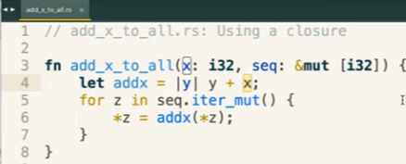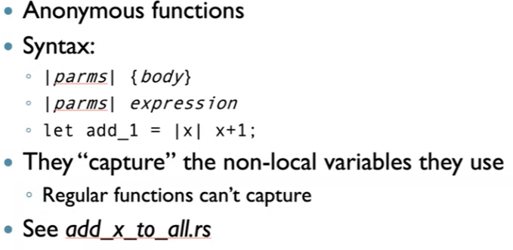

## Closure Types:

Closures are assigned their own **unique** type on the fly, so their type is different from a normal fn function, and therefore cannot be defined using the Type keyword

e.g. Type F = impl Fn(i32) -> i32; will work with fn defined variables, but not with closures!

## Closures as Parameters:



Note the difference between **'Fn'** and **'fn'**



### Closure Parameter Example:



## Returning Closures:

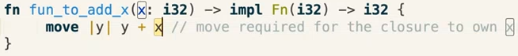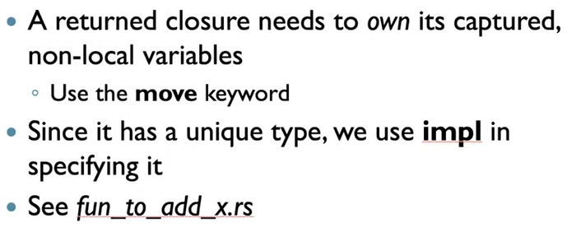

# Iterators & Streams:

see [fib_iter.rs](../Course%20Provided%20Documents/Provided_Code_Samples/fib_iter.rs) [iter.rs](../Course%20Provided%20Documents/Provided_Code_Samples/iter.rs)

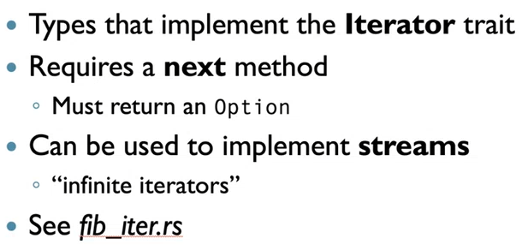

Iterators always return references

## Iterator Consumers:

see [prime2.rs](../Course%20Provided%20Documents/Provided_Code_Samples/prime2.rs)

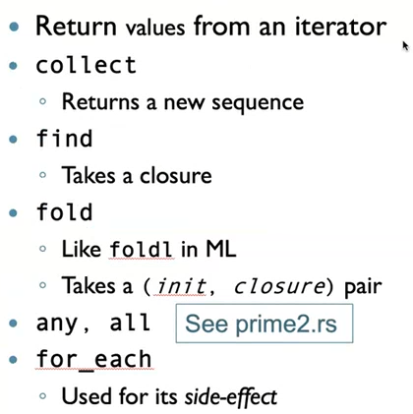

### .for_each()



### .collect()

.collect() takes everything in a range, and throws it into a container.



### .fold()

(a.k.a foldl)

consumes the iterator



## Iterator Adapters:

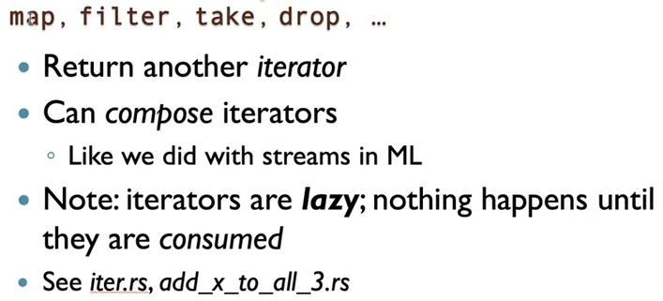

### Chaining Iterator Adapters:

// takes the largest 5 numbers between 1–1000 that are divisible by 6

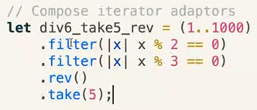



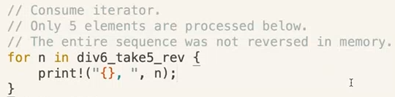

count() consumes



## Implementing an Iterator:

### Defining Class Data:

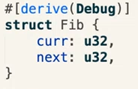

### Adding new() Method To Class:

**'Self'** is a special identifier that represents the type to be implemented **(in this case, 'Self' == 'Fib')**

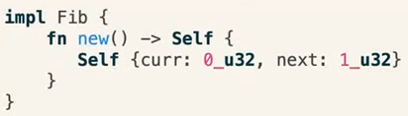

Returns a new Fib object where

curr = 0, and next = 1



### Implementing Iterator Functionality For Class:

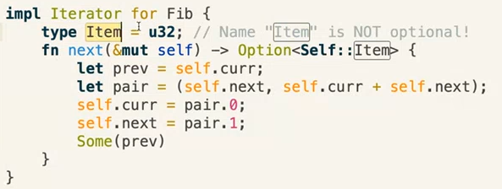

Option<**u32**>

### Executing The Iterator:

